Memory Organization in Computer Architecture

A memory unit is the collection of storage units or devices together. The memory unit stores the binary information in the form of bits. Generally, memory/storage is classified into 2 categories:

* **Volatile Memory**: This loses its data, when power is switched off.
* **Non-Volatile Memory**: This is a permanent storage and does not lose any data when power is switched off.

Memory Hierarchy

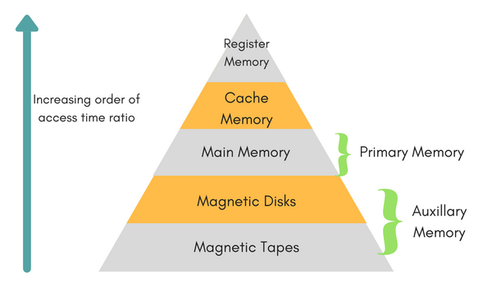

The total memory capacity of a computer can be visualized by hierarchy of components. The memory hierarchy system consists of all storage devices contained in a computer system from the slow Auxiliary Memory to fast Main Memory and to smaller Cache memory.

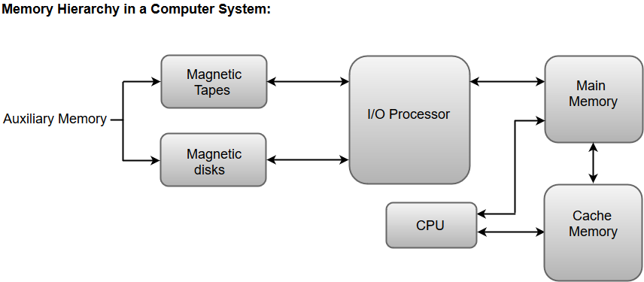

**Auxillary memory** access time is generally **1000 times** that of the main memory, hence it is at the bottom of the hierarchy.

The **main memory** occupies the central position because it is equipped to communicate directly with the CPU and with auxiliary memory devices through Input/output processor (I/O).

When the program not residing in main memory is needed by the CPU, they are brought in from auxiliary memory. Programs not currently needed in main memory are transferred into auxiliary memory to provide space in main memory for other programs that are currently in use.

The **cache memory** is used to store program data which is currently being executed in the CPU. Approximate access time ratio between cache memory and main memory is about **1 to 7~10**

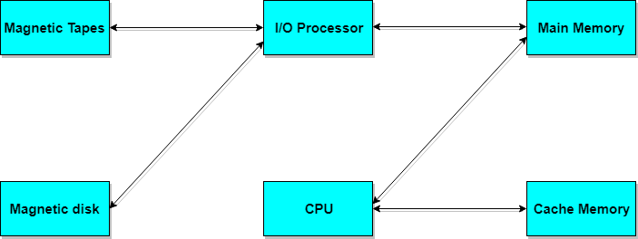

Memory Access Methods

Each memory type, is a collection of numerous memory locations. To access data from any memory, first it must be located and then the data is read from the memory location. Following are the methods to access information from memory locations:

1. **Random Access**: Main memories are random access memories, in which each memory location has a unique address. Using this unique address any memory location can be reached in the same amount of time in any order.
2. **Sequential Access**: This methods allows memory access in a sequence or in order.
3. **Direct Access**: In this mode, information is stored in tracks, with each track having a separate read/write head.

Main Memory

The memory unit that communicates directly within the CPU, Auxillary memory and Cache memory, is called main memory. It is the central storage unit of the computer system. It is a large and fast memory used to store data during computer operations. Main memory is made up of **RAM** and **ROM**, with RAM integrated circuit chips holing the major share.

* RAM: Random Access Memory
  + **DRAM**: Dynamic RAM, is made of capacitors and transistors, and must be refreshed every 10~100 ms. It is slower and cheaper than SRAM.
  + **SRAM**: Static RAM, has a six transistor circuit in each cell and retains data, until powered off.
  + **NVRAM**: Non-Volatile RAM, retains its data, even when turned off. Example: Flash memory.
* ROM: Read Only Memory, is non-volatile and is more like a permanent storage for information. It also stores the **bootstrap loader** program, to load and start the operating system when computer is turned on. **PROM**(Programmable ROM), **EPROM**(Erasable PROM) and **EEPROM**(Electrically Erasable PROM) are some commonly used ROMs.

## RAM integrated circuit chips

The RAM integrated circuit chips are further classified into two possible operating modes, **static** and **dynamic**.

The primary compositions of a static RAM are flip-flops that store the binary information. The nature of the stored information is volatile, i.e. it remains valid as long as power is applied to the system. The static RAM is easy to use and takes less time performing read and write operations as compared to dynamic RAM.

The dynamic RAM exhibits the binary information in the form of electric charges that are applied to capacitors. The capacitors are integrated inside the chip by MOS transistors. The dynamic RAM consumes less power and provides large storage capacity in a single memory chip.

RAM chips are available in a variety of sizes and are used as per the system requirement. The following block diagram demonstrates the chip interconnection in a 128 * 8 RAM chip.

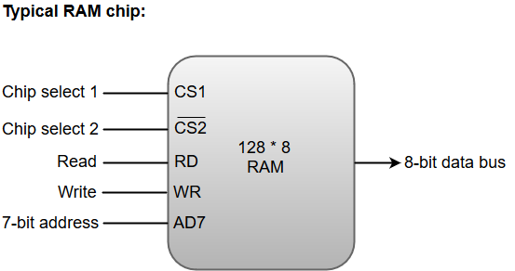

* A 128 * 8 RAM chip has a memory capacity of 128 words of eight bits (one byte) per word. This requires a 7-bit address and an 8-bit bidirectional data bus.
* The 8-bit bidirectional data bus allows the transfer of data either from memory to CPU during a **read** operation or from CPU to memory during a **write** operation.
* The **read** and **write** inputs specify the memory operation, and the two chip select (CS) control inputs are for enabling the chip only when the microprocessor selects it.
* The bidirectional data bus is constructed using **three-state buffers**.
* The output generated by three-state buffers can be placed in one of the three possible states which include a signal equivalent to logic 1, a signal equal to logic 0, or a high-impedance state.

#### **Note: The logic 1 and 0 are standard digital signals whereas the high-impedance state behaves like an open circuit, which means that the output does not carry a signal and has no logic significance.**

The following function table specifies the operations of a 128 * 8 RAM chip.

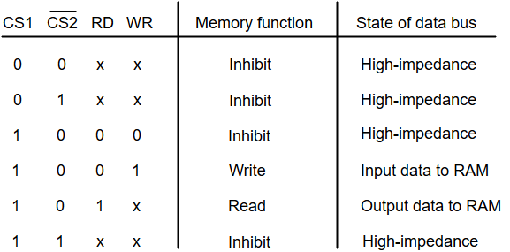

From the functional table, we can conclude that the unit is in operation only when CS1 = 1 and CS2 = 0. The bar on top of the second select variable indicates that this input is enabled when it is equal to 0.

## ROM integrated circuit

The primary component of the main memory is RAM integrated circuit chips, but a portion of memory may be constructed with ROM chips.

A ROM memory is used for keeping programs and data that are permanently resident in the computer.

Apart from the permanent storage of data, the ROM portion of main memory is needed for storing an initial program called a **bootstrap loader**. The primary function of the **bootstrap loader** program is to start the computer software operating when power is turned on.

ROM chips are also available in a variety of sizes and are also used as per the system requirement. The following block diagram demonstrates the chip interconnection in a 512 * 8 ROM chip.

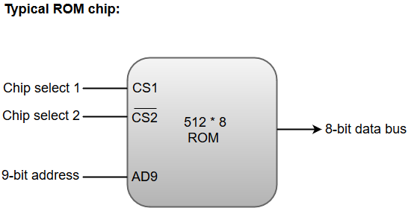

* A ROM chip has a similar organization as a RAM chip. However, a ROM can only perform read operation; the data bus can only operate in an output mode.
* The 9-bit address lines in the ROM chip specify any one of the 512 bytes stored in it.
* The value for chip select 1 and chip select 2 must be 1 and 0 for the unit to operate. Otherwise, the data bus is said to be in a high-impedance state.

Auxiliary Memory

Devices that provide backup storage are called auxiliary memory. **For example:** Magnetic disks and tapes are commonly used auxiliary devices. Other devices used as auxiliary memory are magnetic drums, magnetic bubble memory and optical disks.

It is not directly accessible to the CPU, and is accessed using the Input/Output channels.

Cache Memory

The data or contents of the main memory that are used again and again by CPU, are stored in the cache memory so that we can easily access that data in shorter time.

Whenever the CPU needs to access memory, it first checks the cache memory. If the data is not found in cache memory then the CPU moves onto the main memory. It also transfers block of recent data into the cache and keeps on deleting the old data in cache to accomodate the new one.

The data or contents of the main memory that are used frequently by CPU are stored in the cache memory so that the processor can easily access that data in a shorter time. Whenever the CPU needs to access memory, it first checks the cache memory. If the data is not found in cache memory, then the CPU moves into the main memory.

Cache memory is placed between the CPU and the main memory. The block diagram for a cache memory can be represented as:

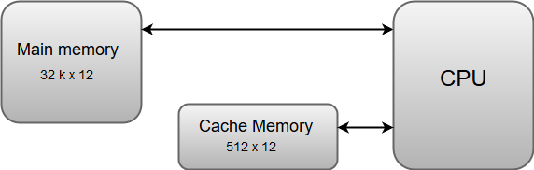

The cache is the fastest component in the memory hierarchy and approaches the speed of CPU components.

The basic operation of a cache memory is as follows:

* When the CPU needs to access memory, the cache is examined. If the word is found in the cache, it is read from the fast memory.
* If the word addressed by the CPU is not found in the cache, the main memory is accessed to read the word.
* A block of words one just accessed is then transferred from main memory to cache memory. The block size may vary from one word (the one just accessed) to about 16 words adjacent to the one just accessed.
* The performance of the cache memory is frequently measured in terms of a quantity called **hit ratio**.
* When the CPU refers to memory and finds the word in cache, it is said to produce a **hit**.
* If the word is not found in the cache, it is in main memory and it counts as a **miss**.
* The ratio of the number of hits divided by the total CPU references to memory (hits plus misses) is the hit ratio.

Associative Memory

It is also known as **content addressable memory (CAM)**. It is a memory chip in which each bit position can be compared. In this the content is compared in each bit cell which allows very fast table lookup. Since the entire chip can be compared, contents are randomly stored without considering addressing scheme. These chips have less storage capacity than regular memory chips.

Magnetic Disks

A magnetic disk is a type of memory constructed using a circular plate of metal or plastic coated with magnetized materials. Usually, both sides of the disks are used to carry out read/write operations. However, several disks may be stacked on one spindle with read/write head available on each surface.

The following image shows the structural representation for a magnetic disk.

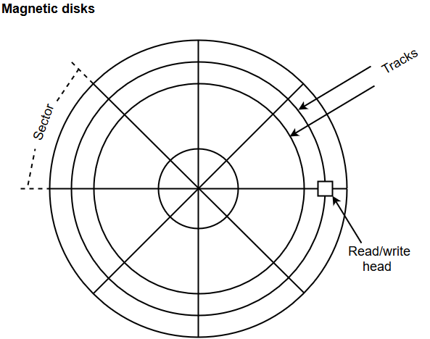

* The memory bits are stored in the magnetized surface in spots along the concentric circles called tracks.
* The concentric circles (tracks) are commonly divided into sections called sectors.

Magnetic Tape

Magnetic tape is a storage medium that allows data archiving, collection, and backup for different kinds of data. The magnetic tape is constructed using a plastic strip coated with a magnetic recording medium.

The bits are recorded as magnetic spots on the tape along several tracks. Usually, seven or nine bits are recorded simultaneously to form a character together with a parity bit.

Magnetic tape units can be halted, started to move forward or in reverse, or can be rewound. However, they cannot be started or stopped fast enough between individual characters. For this reason, information is recorded in blocks referred to as records.

Memory Mapping and Concept of Virtual Memory

The transformation of data from main memory to cache memory is called mapping. There are 3 main types of mapping:

* Associative Mapping
* Direct Mapping
* Set Associative Mapping

Associative Mapping

The associative memory stores both address and data. The address value of 15 bits is 5 digit octal numbers and data is of 12 bits word in 4 digit octal number. A CPU address of 15 bits is placed in **argument register** and the associative memory is searched for matching address.

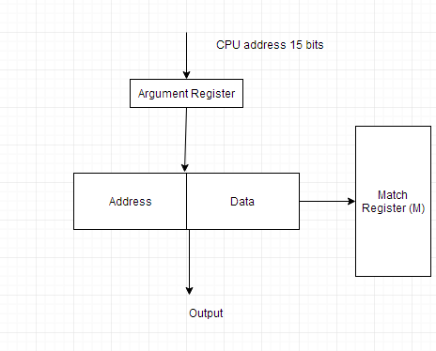

An associative memory can be considered as a memory unit whose stored data can be identified for access by the content of the data itself rather than by an address or memory location.

Associative memory is often referred to as **Content Addressable Memory (CAM)**.

When a write operation is performed on associative memory, no address or memory location is given to the word. The memory itself is capable of finding an empty unused location to store the word.

On the other hand, when the word is to be read from an associative memory, the content of the word, or part of the word, is specified. The words which match the specified content are located by the memory and are marked for reading.

The following diagram shows the block representation of an Associative memory.

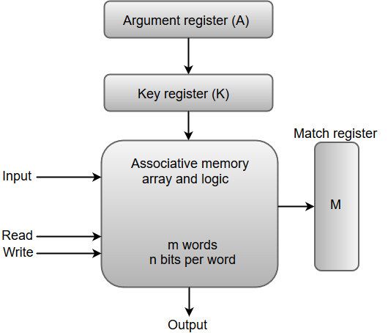

From the block diagram, we can say that an associative memory consists of a memory array and logic for 'm' words with 'n' bits per word.

The functional registers like the argument register **A** and key register **K** each have **n** bits, one for each bit of a word. The match register **M** consists of **m** bits, one for each memory word.

The words which are kept in the memory are compared in parallel with the content of the argument register.

The key register (K) provides a mask for choosing a particular field or key in the argument word. If the key register contains a binary value of all 1's, then the entire argument is compared with each memory word. Otherwise, only those bits in the argument that have 1's in their corresponding position of the key register are compared. Thus, the key provides a mask for identifying a piece of information which specifies how the reference to memory is made.

The following diagram can represent the relation between the memory array and the external registers in an associative memory.

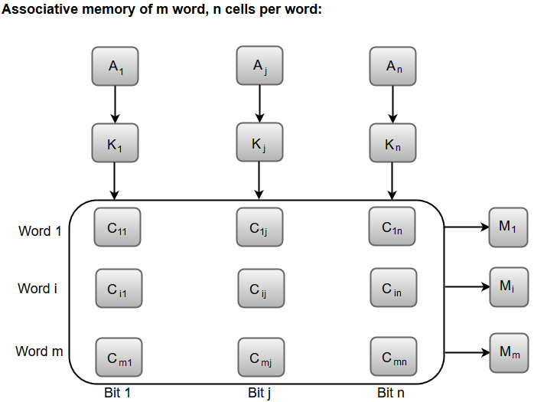

The cells present inside the memory array are marked by the letter C with two subscripts. The first subscript gives the word number and the second specifies the bit position in the word. For instance, the cell Cij is the cell for bit **j** in word **i**.

A bit Aj in the argument register is compared with all the bits in column **j** of the array provided that Kj = 1. This process is done for all columns **j** = 1, 2, 3......, n.

If a match occurs between all the unmasked bits of the argument and the bits in word **i**, the corresponding bit Mi in the match register is set to 1. If one or more unmasked bits of the argument and the word do not match, Mi is cleared to 0.

Direct Mapping

The CPU address of 15 bits is divided into 2 fields. In this the 9 least significant bits constitute the **index** field and the remaining 6 bits constitute the **tag** field. The number of bits in index field is equal to the number of address bits required to access cache memory.

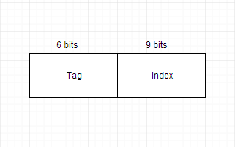

Set Associative Mapping

The disadvantage of direct mapping is that two words with same index address can't reside in cache memory at the same time. This problem can be overcome by set associative mapping.

In this we can store two or more words of memory under the same index address. Each data word is stored together with its tag and this forms a set.

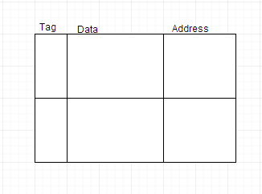

Replacement Algorithms

Data is continuously replaced with new data in the cache memory using replacement algorithms. Following are the 2 replacement algorithms used:

* FIFO - First in First out. Oldest item is replaced with the latest item.
* LRU - Least Recently Used. Item which is least recently used by CPU is removed.

Virtual Memory

Virtual memory is the separation of logical memory from physical memory. This separation provides large virtual memory for programmers when only small physical memory is available.

Virtual memory is used to give programmers the illusion that they have a very large memory even though the computer has a small main memory. It makes the task of programming easier because the programmer no longer needs to worry about the amount of physical memory available.

